1. No, this is an opinion. If there is no definite true/false answer, it is not a proposition.
2. Hikaru is shorter than Yutaka
3. (a)

(b) Some people weigh less than 100 pounds.

1. This statement is true because the premise of the statement is false. Conditionals with a false premise are true
2. If it is pleasant to for you to travel in economy class, then you are 6 feet tall or shorter.
3. Only if: If we could not visit the stars, then we did not have an FTL drive.

Sufficient: If we had an FTL drive, then we could visit the stars.

Necessary: If we do not have an FTL drive, we can not visit the stars.

Contrapositive: If we can not visit the stars, we do not have an FTL drive.

Unless: We could visit the stars unless we did not have an FTL drive.

2. (p →q) → (¬p →¬q) Given

By Equivalency By Equivalency By De Morgan By Distribution By Absorption By Equivalency

(a)

Consider all cases of Ak, Bk:

|  |  |  |
| --- | --- | --- |
| Ak | Bk | Ck |
| 0 | 0 | 0 |
| 0 | 1 | 1 |
| 1 | 0 | 1 |
| 1 | 1 | 0 |

In the case drive A failed, Anew = Bk XOR Ck

|  |  |  |
| --- | --- | --- |
| Bk | Ck | A­new |
| 0 | 0 | 0 |
| 1 | 1 | 0 |
| 0 | 1 | 1 |
| 1 | 0 | 1 |

Anew is the same as the original Ak.

Additionally, this also works to recover drive B: Bnew = A­k XOR Ck

(b)

No, using AND would require both inputs to be high for Ck to be used to recover the information.

|  |  |  |
| --- | --- | --- |
| Bk | Ck | A­new |
| 0 | 0 | 0 |
| 1 | 0 | 0 |
| 0 | 0 | 0 |
| 1 | 1 | 1 |

­Ck ­values were changed to match the original values of Ak. Anew ≠ Ak following the rule, Anew = Bk AND Ck.

There are fewer high values saved in Anew

(c)

No, using OR would allow for high value to be saved to Ck more often. Using the same example as in B following the rules Ck = Ak OR Bk, and Anew = Ck ­OR Bk

|  |  |  |
| --- | --- | --- |
| Bk | Ck | A­new |
| 0 | 0 | 0 |
| 1 | 1 | 1 |
| 0 | 1 | 1 |
| 1 | 1 | 1 |

There are more high values saved in Anew.

1. True, there exists x = 0 which makes any value of y in the domain of discourse equal 0.
2. No, say P(x) = x > 5 and Q(x) = x ≤ 5. If P(4) Q(6), both predicates are false. Whereas, ∀x(P (x) ∨Q(x)), would be true.
3. For every x, there is a unique y and unique z such that x is friends with y and z.
4. False, it could be possible that x does not have any friends, or has one friend.

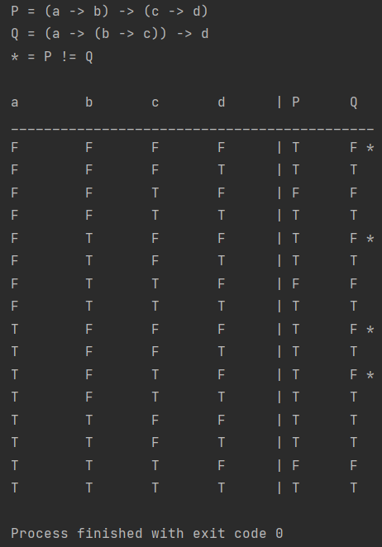

EXTRA CREDIT:

